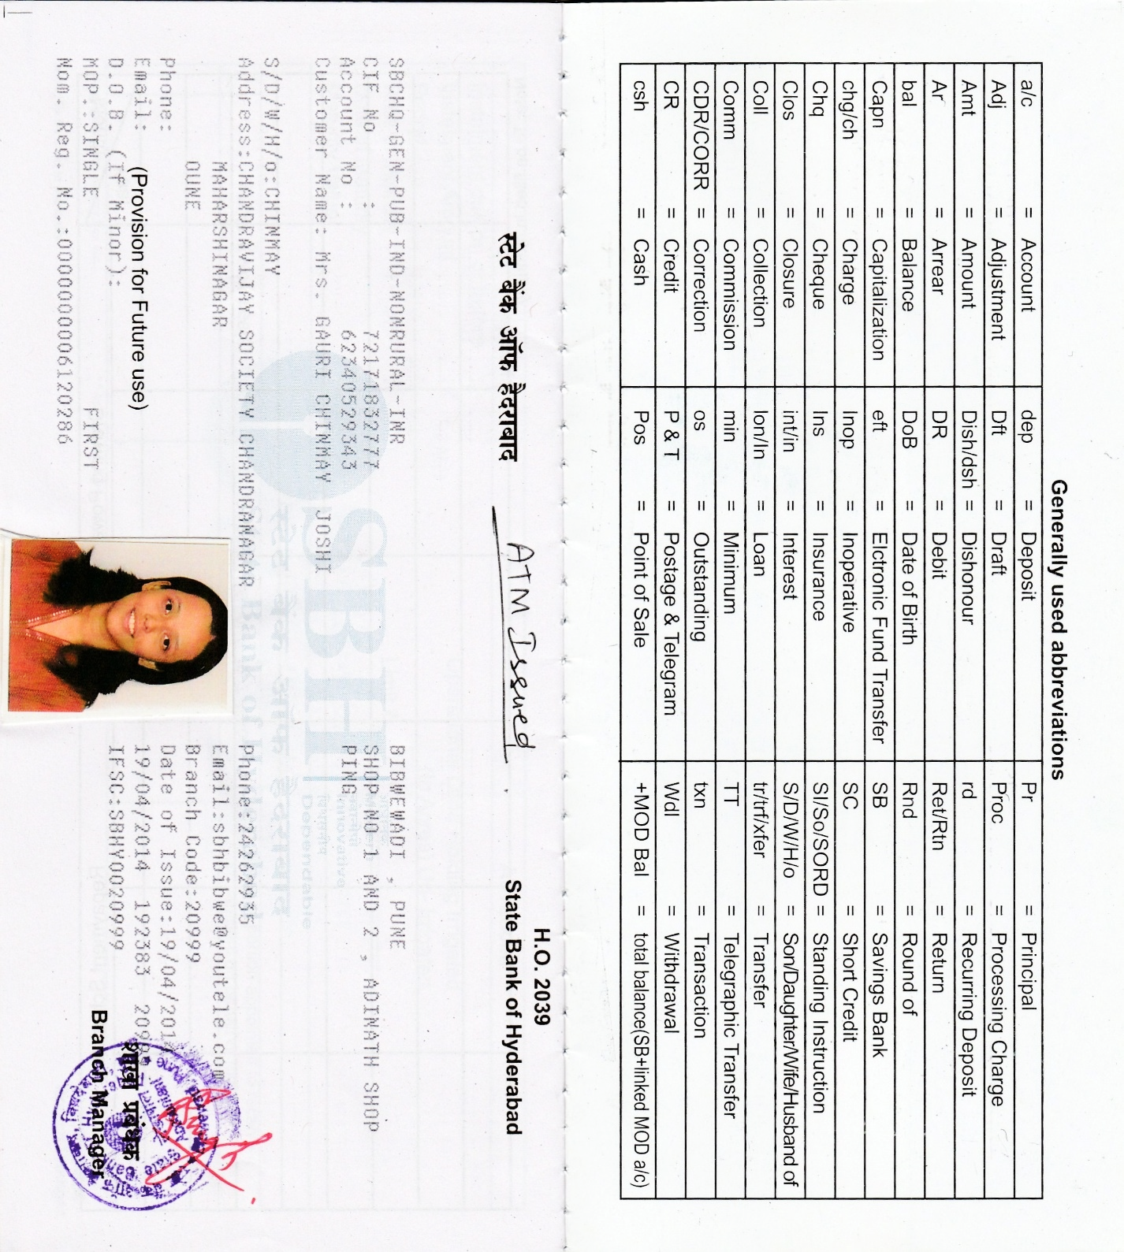

**Gauri Joshi**

She has done her Msc Computer Science from Ruia College Matunga Mumbai (Mumbai University)

She works as a Computer Teacher at Dr Kalmadi Shamarao High School

* She has developed computer training materials (at school level).
* She has demonstrated advanced level knowledge in Windows, Microsoft Office.

**______________________________________________________________________________**

**5 E Lesson Plan**

1. ***General Information***
2. Name of the School: Dr. Kalmadi Shamarao Highschool, Ganeshnagar
3. Name of the Teacher: Gauri Joshi
4. Date: 19.11.2018
5. Subject: Computer
6. Grade: V-VI
7. Topic: Hardware & Software
8. State Curriculum Standards: C.B.S.E
9. ***Lesson / Unit Planning:***
10. **Short Description of the Concept:** Computer hardware is any physical device used in or with your machine, whereas software is a collection of code installed onto your computer's hard drive.
11. **Statement of Learning Objectives:**

The student will be able to –

1. **Recognize** the importance of computer literacy.
2. **Describe** the term computer hardware & software and identify its components.
3. **Explain** why a computer is a powerful tool.
4. **Recognize** the purpose of storage devices.
5. **Discuss** the uses of the Internet and World Wide Web.
6. **Recognize** the difference between installing and running an application program & perform the same in lab.
7. **Identify** the types of software.(Application software/System software)
8. **Distinguish** between system software & application software
9. **Prepare** a list of various computer applications in society
10. **Differentiation strategies to meet diverse learner needs:**

Ask the students –

1. If they have seen hardware ,input, output devices of computer
2. Name them?
3. Name the manufacturing company?
4. For a talkative and orally expressive student:

Observe the device and tell its features (properties).Categorize & Name different parts of computer-Worksheets (end of page)

For the students who are able to express through written work:

Recall about different devices and where you will be able to find the devices with embedded computers in it.

* Note: Point (a) and (b) is applicable to average and below average students whereas the following point

5. **Adaptations / Accommodations’ for Exceptional Students:**

Pose the following question-

Distinguish Input devices & Output devices? Elaborate.

Create a mind map showing distinction between Input devices & Output devices using Popplet software.

6. **Safety measures/Precautions:** Each child should work independently & they should take precaution if they are downloading a new software from internet. If you notice any type of smoke or smell, immediately stop what you’re doing and unplug the system

1. *Instructional Process*
2. **Engage**

Take children in computer lab. Show them devices and ask the following questions-

1. How many computers are in lab?
2. Which OS is used in your lab?
3. Write the configuration of each computer?

Software-System software & Application software.

1. **Explore**

* Note: Before starting with the lesson ask each student to paste any 2 pictures on parts of computer in their book & label the part. Explore how their lives be different without the computers they have used already. How much time did they save by using that type of computer?

1. **Explain**

Tr. explains the working & features of different devices.

PPT showcasing the different points about Hardware & Software.

1. **Elaborate**

In reference to the context above the teacher shows the video on above topic

<https://www.youtube.com/watch?v=wwnQ9_PIYeU>

<https://www.youtube.com/watch?v=dFHW7MCsV3I>

1. **Evaluate**
2. Tell the students to read the information of each device. Name it & categorize it.
3. Kahoot Quiz
4. Worksheets (end of page)
5. Additional question-

* How else will you be using a computer today? As you move through your campus today,
* Observe how computers are being used right here in your environment.

**Digital Citizenship**

Now that we have technology in our classrooms, "how do we help children effectively use digital tools?”

* As technology leaders, our goal should be to help our students **become their best selves online**. It can be achieved with help of Digital citizenship.
* When we teach digital citizenship in schools, we are teaching students **to be appropriate and use technology responsibly**.
* Digital citizenship is important; to help students to learn, communicate and collaborate safely and responsibly. Being a best digital citizen in the community includes having email etiquette, reporting and preventing cyber bullying, learning how to protect private information, etc.

Here are some scenarios given to students where they need to follow digital citizenship rules.

|  |  |  |  |
| --- | --- | --- | --- |
| **Situation/Scenario** | **Wrong** | **Right** | **What can be done** |
| Sara was asked to do a project on History  Topic-Famous leaders.  She creates a beautiful PPT and adds images of leaders. She adds the image by doing a Google image search. | She does not give credits to source of her photos. There is no slide in her PPT mentioning photos or source Google. She assumes that Google has posted the photos. | She should acknowledges the source at bottom of each photo that she enters in to PPT. She makes it a point to share with her classmates. | She must be aware about the concept called copyrights. She should try to learn more on search engines and how to locate images that are intended for educational use. |

The above scenario depicts Digital Rights & responsibilities with concept of Copyright & other digital citizenship rules.

We can put different scenarios based on nine elements of digital citizenship & include it in every class/lab sessions at the end. This helps them to develop a responsible digital citizen.

1. ***References / Resources***

Sources/Materials/References

Textbook-Digitech Optima publication

Google

General Information

1. Name of the School: Dr. Kalmadi Shamarao Highschool, Ganeshnagar
2. Name of the Teacher: Gauri Joshi
3. Date: 19.11.2018
4. Subject: Computer CBSE Board
5. Grade: V-VI
6. Topic: Hardware & Software

|  |  |
| --- | --- |
| Topic: | Computer-Hardware & Software |
| Content: | What is a Computer? -Components |
| Goals: | To help students understand the relevance of computers in our society.  To help students understand the difference between software and hardware.  To introduce students to the various categories of computers. |
| Objectives: | 1. Recognize the importance of computer literacy.  2. Describe the term computer and identify its components.  3. Explain why a computer is a powerful tool.  4. Recognize the purpose of storage devices  5. Discuss the uses of the Internet and World Wide Web  6. Recognize the difference between installing and running a program & perform the same in lab.  7. Identify the types of software.  8.Distinguish between system software & application software  9. Identify the types of computer users.  10. Prepare a list of various computer applications in society. |
| Introduction: | "Life without computers" -Intro- We all know that we couldn't make it without computers in this day and age, but really think about how your life would be affected without the everyday use of computers. |
| Development: | 6-8 Sessions(periods)  Opening Activity Have students write on a sheet of paper, the following   1. Three ways they have used a computer already that day. Randomly choose and ask for volunteers to share the answers. Explore how their lives be different without the computers they have used already. 2. How much time did they save by using that type of computer? 3. What is a computer? -electronic device -Data and Information -Information Processing Cycle Introduce the Components of a Computer -Hardware -Input Devices -Output Devices -System Unit -Storage devices – 4. Software-System software & Application software. |
| Assignments/Worksheets/Lab practicals | 1. Visually go through the components of a computer using my computer. Have students categorize the various components as input, output, hardware, software, storage device. 2. Identify whether it is a system software or application software-worksheet 3. Categorize & Name different parts of computer-Worksheets (end of page) |
| Closure: | 1. How else will you be using a computer today? As you move through your campus today, 2. Observe how computers are being used right here in your environment. 3. How many computers are in your lab. 4. Give the configuration of the computer that you use |

**Digital Citizenship**

Now that we have technology in our classrooms, "how do we help children effectively use digital tools?”

* As technology leaders, our goal should be to help our students **become their best selves online**. It can be achieved with help of Digital citizenship.
* When we teach digital citizenship in schools, we are teaching students **to be appropriate and use technology responsibly**.
* Digital citizenship is important; to help students to learn, communicate and collaborate safely and responsibly. Being a best digital citizen in the community includes having email etiquette, reporting and preventing cyber bullying, learning how to protect private information, etc.

Here are some scenarios given to students where they need to follow digital citizenship rules.

|  |  |  |  |
| --- | --- | --- | --- |
| **Situation/Scenario** | **Wrong** | **Right** | **What can be done** |
| Sara was asked to do a project on History  Topic-Famous leaders.  She creates a beautiful PPT and adds images of leaders. She adds the image by doing a google image search. | She does not give credits to source of her photos. There is no slide in her PPT mentioning photos or source Google. She assumes that Google has posted the photos. | She should acknowledges the source at bottom of each photo that she enters in to PPT. She makes it a point to share with her classmates. | She must be aware about the concept called copyrights. She should try to learn more on search engines and how to locate images that are intended for educational use. |

The above scenario depicts Digital Rights & responsibilities with concept of Copyright & other digital citizenship rules.

We can put different scenarios based on nine elements of digital citizenship & include it in every class/lab sessions at the end. This helps them to develop a responsible digital citizen.

**Sources/Materials/References**

Textbook-Digitech Optima publication

https://sites.google.com/site/digitalcitizenshipinyourschool

**Video on Hardware & software**

<https://www.youtube.com/watch?v=wwnQ9_PIYeU>

<https://www.youtube.com/watch?v=dFHW7MCsV3I>

**Difference between sys s/w & application s/w**

<https://www.youtube.com/watch?v=hT53o2hLDIc>

**Input, Output & storage devices**

<https://www.youtube.com/watch?v=74YuS4IuywQ>

<https://www.youtube.com/watch?v=b7uwVe7M8Pg>

Worksheets on Input, Output & Storage devices

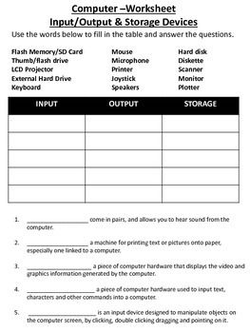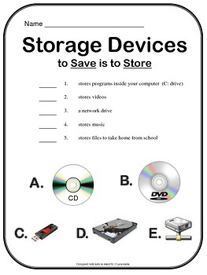

* Similar worksheets can be designed in PPT and also can be modified using Kahoot for quiz.You can design the rubric for the same using Rubistar.com.  
    
  